

**Signals and Systems**

Lab Report#12

# Name:

Taha Saeed

**Registration number:**

FA18-EEE-032

**Submitted to:**

Dr. Ghufran Shafiq

**Pre-Lab**

**Task 01: Compute the unilateral Laplace transform of the function . Also evaluate the inverse Laplace transform of your result.**

**Solution:**

clear all;

clc;

syms t s

f=-1.25+(3.5*t*exp(-2*t))+1.25*exp(-2*t);

a=laplace(f,s)

b=ilaplace(a,t)

**Result:**

a =5/(4*(s + 2)) + 7/(2*(s + 2)^2) - 5/(4*s)

b =5/(4*exp(2*t)) + (7*t)/(2*exp(2*t)) - 5/4

**Task 02: Compute the unilateral Laplace transform of the function .**

**Solution:**

clear all;

clc;

syms t s

f=1;

a=laplace(f,s)

**Result:**

a =1/s

**Task 03: Express in the partial fraction form the signal**



**Solution:**

clear all;

clc;

num=[1 0 -3 2];

den=[1 4 5];

[r p k]=residue(num,den);

syms s

X=r(1)/(s-p(1))+r(2)/(s-p(2))+k;

pretty(X)

**Result:**

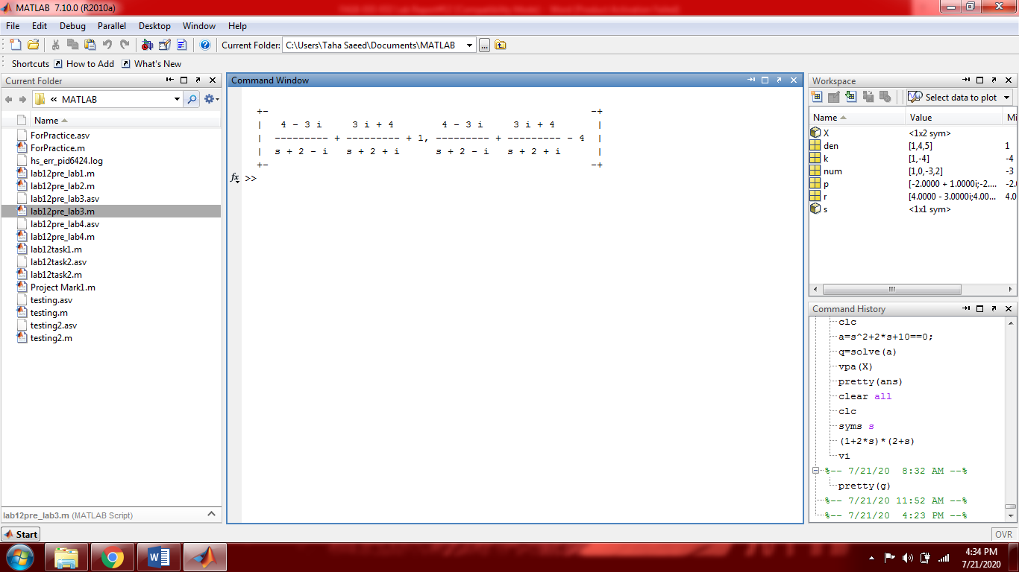

**Task 04: Express in the partial fraction form the signal**



**Verify your result by computing the inverse Laplace transform from both forms (partial fraction and rational) and plot both of the results.**

**Solution:**

clear all;

clc;

num=[1 5 4];

den=[1 0 0 0 1];

[r p k]=residue(num,den);

syms t s

X=r(1)/(s-p(1)) + r(2)/(s-p(2)) + r(3)/(s-p(3)) + r(4)/(s-p(4));

x1=ilaplace(X,t);

x1=vpa(x1);

figure(1)

ezplot(x1,[-35,35]);

title('ilaplace of partial fraction');

T=(s^2+5*s+4)/(s^4+1);

T=vpa(T);

x2=ilaplace(T,t);

figure(2)

ezplot(x2,[-35,35]);

title('ilaplace of rational fraction');

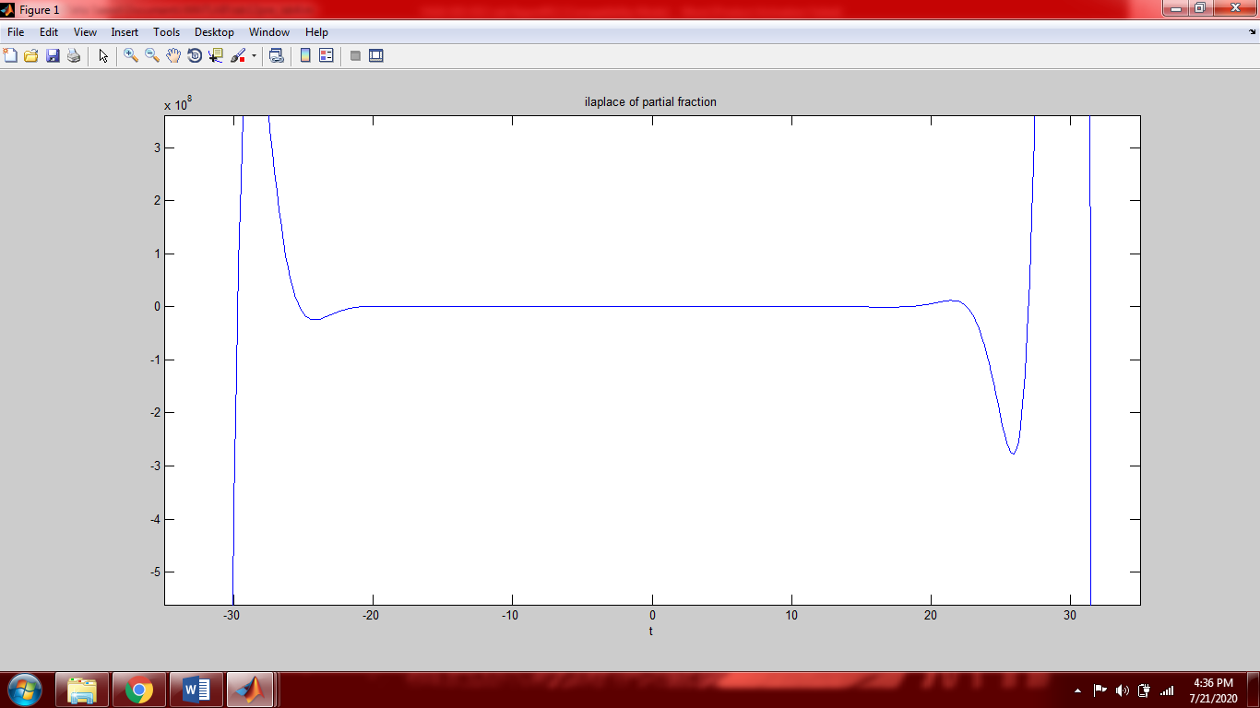

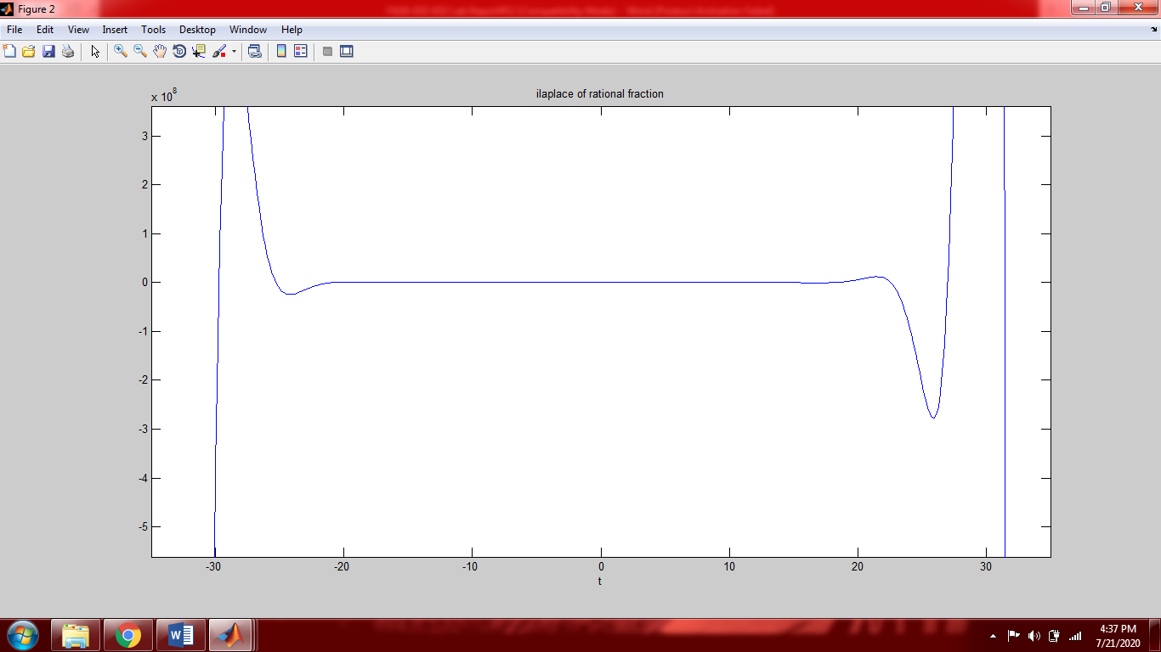

**In-Lab Open ended Tasks**

**Task 01: Examine the network shown in figure 12.1 below. Assume the network is in steady state prior to.**

1. **Plot the output current for**
2. **Determine whether the system is stable or not?**

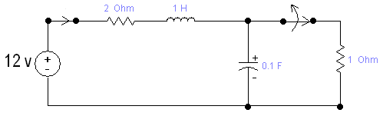

**Figure 12.1**

**Solution:**

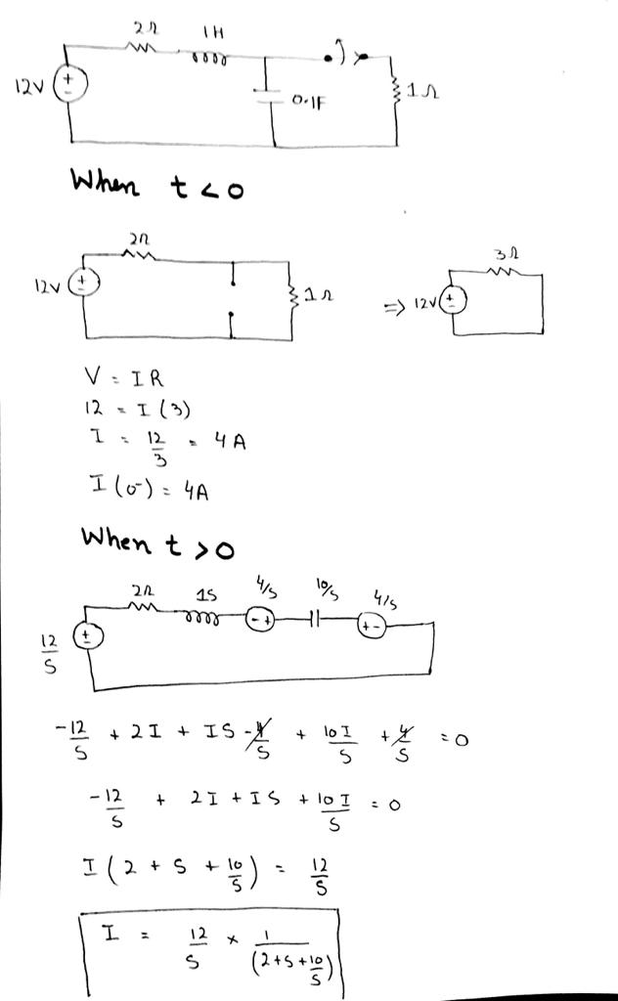

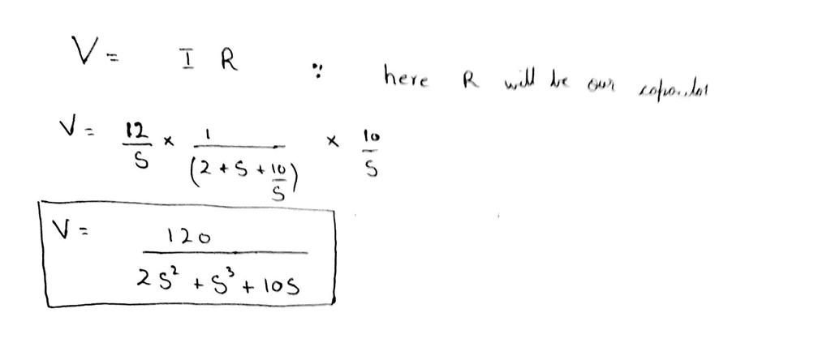

**Code:**

close all;

clear all;

clc;

syms t s

vi=12; %12 volts input

Vi=laplace(vi,s);

I=Vi/(2+s+10/s);

i=ilaplace(I,t);

ezplot(i,[0,10]);

title('current for t>0')

Vo=I*(10/s); %V=IR here R is capacitor

G=Vo/Vi;

pretty(G)

g=ilaplace(G,t);

%figure(2)

%ezplot(g,[0,10]);

%now converting G into partial fraction

num=[10];

den=[1 2 10];

[r p k]=residue(num,den);

syms s

X=r(1)/(s-p(1))+r(2)/(s-p(2));

pretty(X);

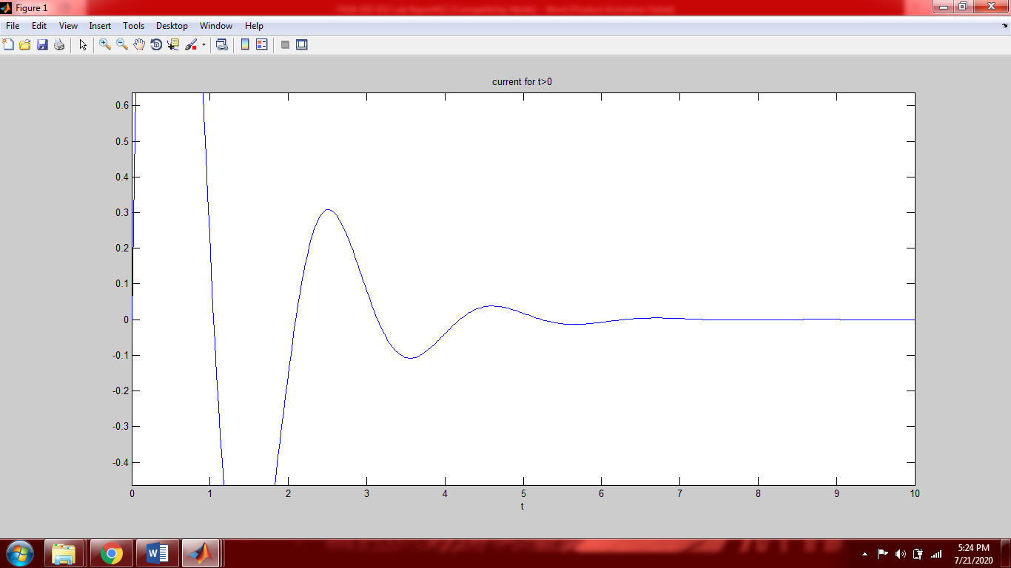

**Result:**

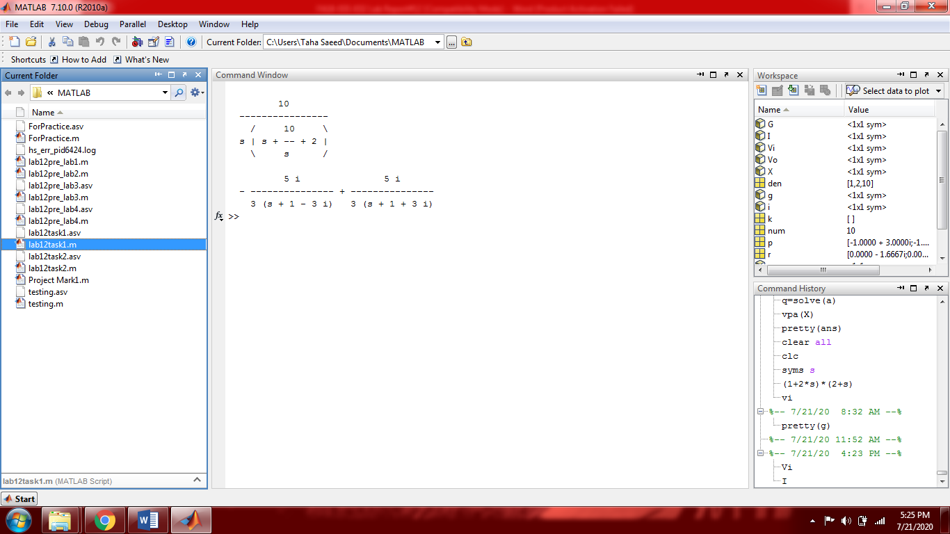

As we can see that the poles of the above transfer function are less than zero (all poles are negative) it means that they are located on the left-hand plane (LHP). Therefore the system is stable.

**Task 02: For the circuit shown in figure 12.2, the input voltage is**

1. **Plot the steady state output voltage for assuming zero initial conditions.**
2. **Determine whether the system is stable or not?**

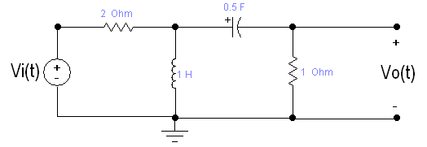

**Figure 12.2**

**Solution:**

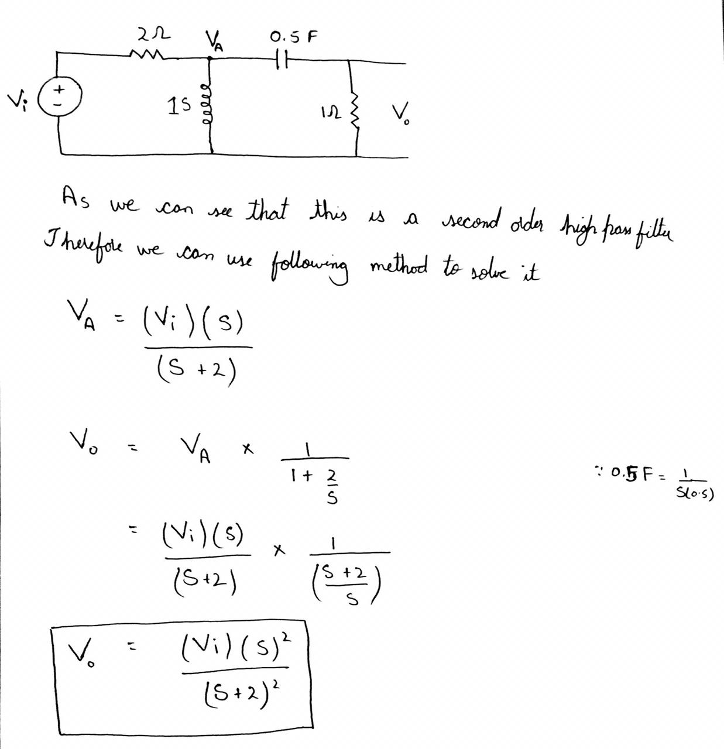

**Code:**

close all;

clear all;

clc;

syms t s

vi=10*cos(2*t).*heaviside(t);

Vi=laplace(vi,s);

Vo=Vi.*(s^2)/(s+2)^2;

vo=ilaplace(Vo,t);

ezplot(vo,[0,10]);

title('voltage for t>0')

G=Vo/Vi;

pretty(G)

g=ilaplace(G,t);

%figure(2)

%ezplot(g,[0,10])

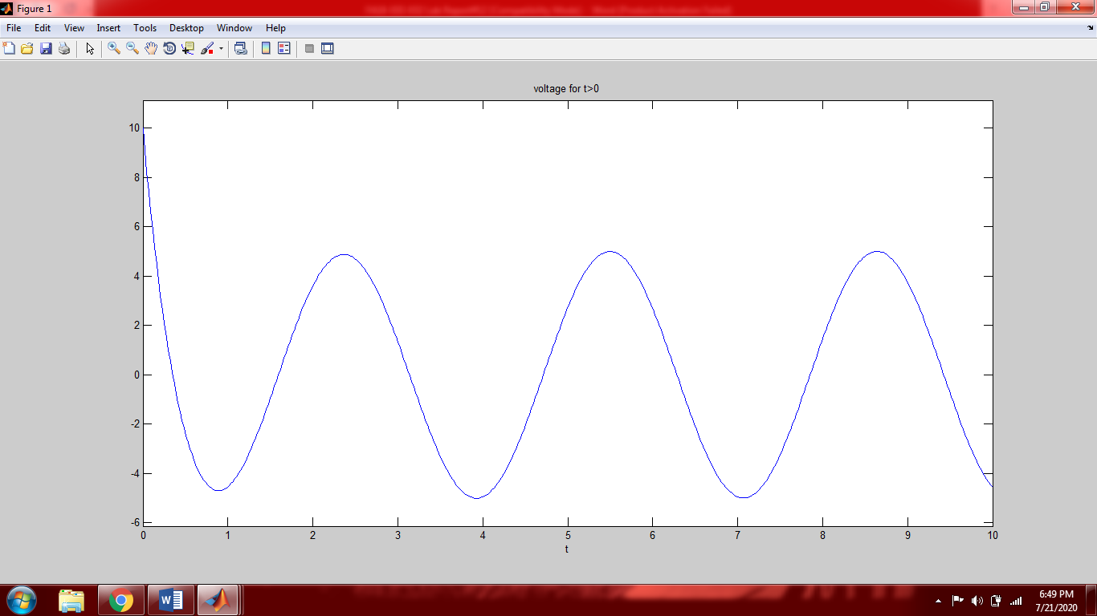

**Result:**

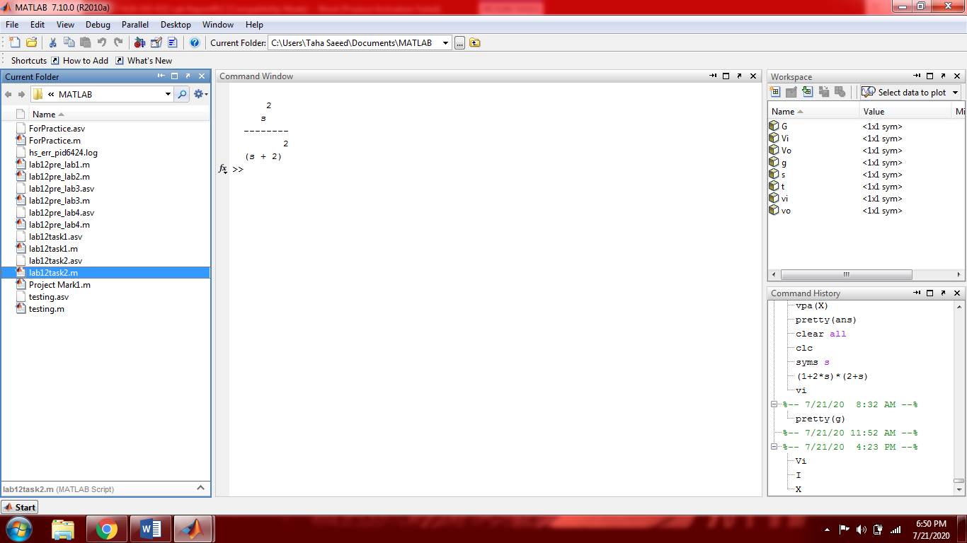

As we can see that the above transfer function is improper. Therefore an improper system cannot be stable.

**Post Lab:**

**Conclusion:**

In this lab we took laplace transform and inverse laplace transform of functions by using the built in command. The residue command was used for partial fraction expansion. In the in–lab tasks we calculated the transfer function of the system and determined whether it was stable or not.

Conditions for stability:

When the poles of the system are less than zero ( all poles are negative) then the system is stable. If we plot the poles they will be on the left-half plane (LHP). If any of the poles is positive the system will be unstable and will be on the right-half plane (RHP).

An improper system( improper transfer function) will be unstable.